Solve $2^{x}+x-2=0$

A. Preliminary investigations

Let $f\left(x\right)=2^{x}+x-2$
$f '\left(x\right)={\ln\left(2\right).2}^{x}+1>0$
Therefore $f\left(x\right)$ is an increasing function.
$f\left(0\right)=2^{0}+0-2=-1<0$
$f\left(1\right)=2^{1}+1-2=1>0$
Since there is a sign change, we have one (or more) real root $x_{0}$, such that $0<x_{0}<1$.

B. Graphical method
$$2^{x}+x-2=0⟺\left\{\begin{aligned}y=2^{x} \\ y=2-x\end{aligned}\right.$$

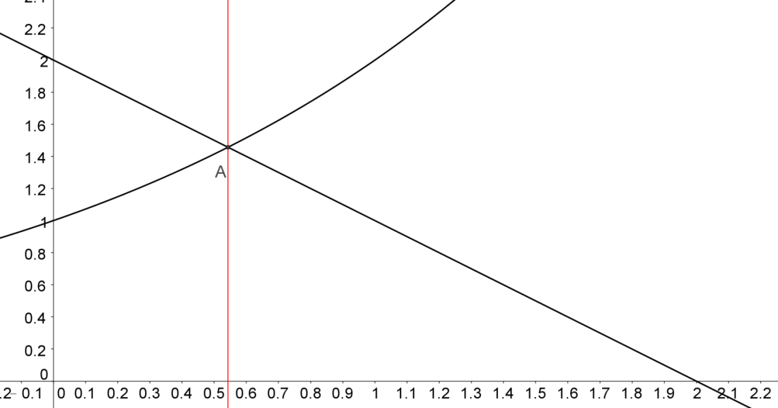
The graphs show that there is a root $x_{0}$, such that $0.4<x_{0}<0.5$.

C. Numerical analysis (See Support document : Numeral method.xlsx)

(1) Bisection method
The Bisection Method
Given a continuous function f(x) in an interval [a , b] and f(a) and f(b) are of opposite signs (There is at least one zero crossing within the interval.)
1. Find the mid-point $c=\frac{a+b}{2}$.
2. Find $f\left(c\right)$.
3. Replace $\left(a,f(a)\right) or \left(b,f(b)\right)$ with $\left(c,f(c)\right)$ so that there is zero crossing in the new interval.
4. Repeat 1 – 3 until $f(c)$ is sufficiently close to zero, and $c$ is the approximate root.

We use EXCEL to get the iterations as below:
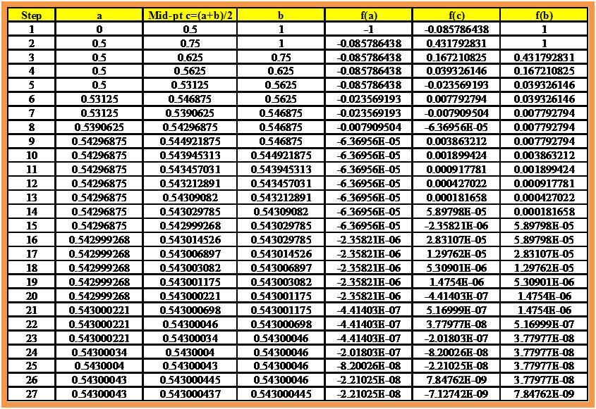
In each step, we discard half of the interval of the previous step. The method is slow and we get the root of $2^{x}+x-2=0$ to be $x≈\underline{\underline{0.5430004}}$, to 7 decimal places in 27 steps.

(2) Newton-Raphson Method
Newton-Raphson Method
Choose $x_{0}$ as initial value and use the formula: $x_{n}=x_{n-1}-\frac{f(x_{n-1})}{f^{'}(x_{n-1})}$
repeatedly to get the solution until we get a sufficiently small error. (We do not discuss error estimation here and in later methods)

Since $f '\left(x\right)={\ln\left(2\right).2}^{x}+1$, the iterative formula is therefore: $x_{n}=x_{n-1}-\frac{2^{x_{n-1}}+x_{n-1}-2}{{\ln\left(2\right).2}^{x_{n-1}}+1}$
and we choose $x_{0}=1$ as the starting point.
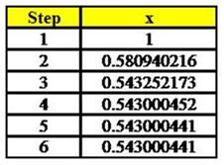
∴The root of $2^{x}+x-2=0$ to be $x≈\underline{\underline{0.5430004}}$, to 7 decimal places in 6 steps.
Newton's method assumes the given function f to have a continuous derivative. The method may not converge if started too far away from a root. However, when it does converge, it is faster than the bisection method.

The above graph shows a little bit of how the Newton's method works. The red line denotes the function ${y=f(x)=2}^{x}+x-2$. At A, the starting point $x_{0}=1$, we draw a vertical line which cuts the function at B. From B, we draw a tangent line BC which cuts the x-axis again at $x_{1}$. We continue the same way to get point D and then $x_{2}$ (not shown) The gradient of the tangent BC is $f '\left(x_{0}\right)$ which is equal to $\frac{BA}{AC}$.
$$f {'\left(x_{0}\right)}^{}=\frac{BA}{AC}=\frac{f\left(x_{0}\right)}{x_{0}-x_{1}}$$
We get $x_{1}=x_{0}-\frac{f\left(x_{0}\right)}{f^{'}\left(x_{0}\right)}$. On deduction we get the Newton-Raphson formula: $x_{n}=x_{n-1}-\frac{f(x_{n-1})}{f^{'}(x_{n-1})}$

(3) Secant Method
The secant method is defined by the recurrence relation
$x_{n}=x_{n-1}-f\left(x_{n-1}\right)\frac{x_{n-1}-x_{n-2}}{f\left(x_{n-1}\right)-f\left(x_{n-2}\right)}=\frac{x_{n-2}f\left(x_{n-1}\right)-x_{n-1}f\left(x_{n-2}\right)}{f\left(x_{n-1}\right)-f\left(x_{n-2}\right)}$
As can be seen from the recurrence relation, the secant method requires two initial values, x₀ and x₁, which should ideally be chosen to lie close to the root.

We choose $x_{0}=1, x_{1}=2$ as our starting values.
$$x_{n}=\frac{x_{n-2}f\left(x_{n-1}\right)-x_{n-1}f\left(x_{n-2}\right)}{f\left(x_{n-1}\right)-f\left(x_{n-2}\right)}=\frac{x_{n-2}\left(2^{x_{n-1}}+x_{n-1}-2\right)-x_{n-1}\left(2^{x_{n-2}}+x_{n-2}-2\right)}{\left(2^{x_{n-1}}+x_{n-1}-2\right)-\left(2^{x_{n-2}}+x_{n-2}-2\right)}$$
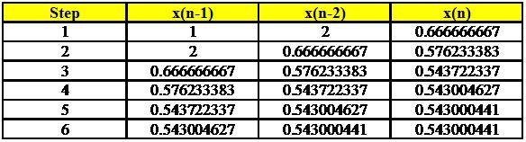
∴The root of $2^{x}+x-2=0$ to be $x≈\underline{\underline{0.5430004}}$, to 7 decimal places in 6 steps.
The diagram shows how the secant method works:
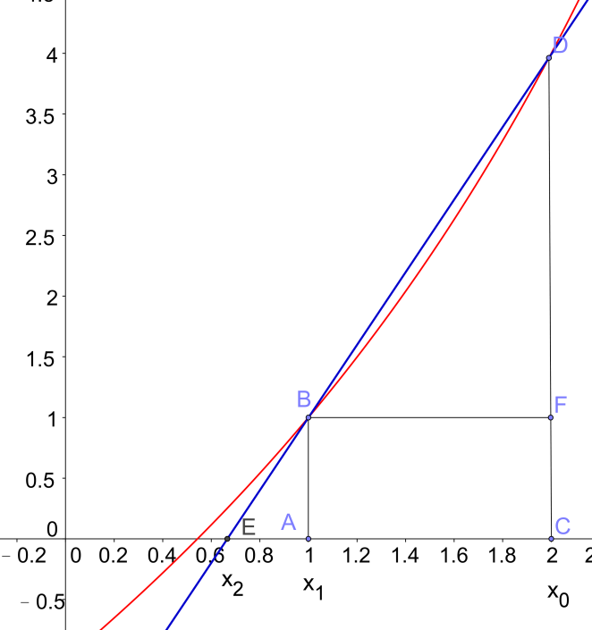
The red line denotes the function ${y=f(x)=2}^{x}+x-2$.
At A and C, the starting points $x_{0}=2{,x}_{1}=1$. DB is the secant or chord which meets the x-axis again at $x_{2}$. Since $∆EAB\sim ∆BFD$, we have
$\frac{AE}{BA}=\frac{FB}{DF} ⟹\frac{x_{1}-x_{2}}{f\left(x_{1}\right)}=\frac{x_{0}-x_{1}}{f\left(x_{0}\right)-f\left(x_{1}\right)} ⟹\frac{x_{2}-x_{1}}{-f\left(x_{1}\right)}=\frac{x_{1}-x_{0}}{f\left(x_{1}\right)-f\left(x_{0}\right)}⟹x_{2}=x_{1}-f\left(x_{1}\right)\frac{x_{1}-x_{0}}{f\left(x_{1}\right)-f\left(x_{0}\right)}$
Now, we get a new set of initial points $x_{1}{,x}_{2}$ and we draw another secant line, deductively, we get:
$$x_{n}=x_{n-1}-f\left(x_{n-1}\right)\frac{x_{n-1}-x_{n-2}}{f\left(x_{n-1}\right)-f\left(x_{n-2}\right)}$$

(4) Fixed Point Iteration Method

Fixed Point Iteration Method
Given $f\left(x\right)=0$
Convert the equation in the form $x=g(x)$.
Let the initial value be $x_{0}$ and use the iterative formula $x_{n+1}=g\left(x_{n}\right)$
Stop at $\left|x_{n+1}-g\left(x_{n}\right)\right|<ϵ$, some tolerance limit.
Convergence condition: $\left|g'\left(x\right)\right|<1$ for all x in an interval near the root of $f\left(x\right)=0$.

You can make quite a lot of iterative formulas, but most of them do not converge:
1. $2^{x}+x-2=0⟹x=2-2^{x}⟹x_{n+1}=2-2^{x_{n}}$
2. $2^{x}+x-2=0⟹2^{x}=2-x⟹x ln 2=\ln{(2-x)⟹}x_{n+1}=\frac{\ln{(2-x_{n})}}{\ln{2}}$
3. $2^{x}+x-2=0⟹x=2^{x}+2x-2⟹x_{n+1}=2^{x_{n}}+2x_{n}-2$

Since we know the root $x_{0}$, such that $0<x_{0}<1$, we use the mid-point as initial value $x_{0}=0.5.$

Tests using EXCEL confirms that the iterative formulas in 1 and 3 cannot work and in 2, the iterative formula converges very slowly and after more than one thousand steps we get our root $x≈\underline{\underline{0.5430004}}$
Although Fixed Point Iteration Method does not work well in this example, it is a good method for other examples.

D. Lambert W-function

This problem can also be solved using Lambert W-function. The W-function is defined as the inverse of
$$f\left(x\right)=xe^{x}$$
that is, $x=W\left(xe^{x}\right)$ and $z=W\left(z\right)e^{W\left(z\right)}$ .

Now, $2^{x}+x-2=0⟹2^{x}=2-x⟹2^{2-t}=t,$ where $t=2-x$
So, $\frac{2^{2}}{2^{t}}=t⟹ 4=t{×2}^{t}=t{×e}^{t log 2} ⟹4\log{2=} \left(t log 2\right){×e}^{t log 2}$
Hence $W\left(4\log{2}\right)=t log 2⟹t=\frac{W\left(4\log{2}\right)}{log 2}$
Finally, we have $x=2-\frac{W\left(4\log{2}\right)}{log 2}=\frac{2\log{2-W\left(4\log{2}\right)}}{log 2}≈\underline{\underline{0.543}}$.

Exercise Find the root $x_{0}$ of $2^{x}=x^{2}$ such that $-1<x_{0}<0$.
(Note that we omit the two other real roots x = 2 , 4.)

